**Nuh (alaihi-salaam)**

1. **Who was Prophet Nuh (alaihi-salaam)?**   
   **________________________________________________________________________________________________**
2. **Why did Allah send him as a messenger?**   
   **________________________________________________________________________________________________**
3. **How were the people in Nuh's alaihi-salaam community living?**   
   **________________________________________________________________________________________________**
4. **What did Allah command Nuh (alaihi-salaam) to do? Why?**   
   **________________________________________________________________________________________________**
5. **How did the people who did not listen to Nuh react?**  
   **________________________________________________________________________________________________**
6. **Who went into the ark?**  
   **________________________________________________________________________________________________**
7. **Complete the word puzzle below.** The letters to the sentence have all been jumbled up, you need to use all the letters to make a sentence. (Hint, question 1 may be able to give you a clue!)

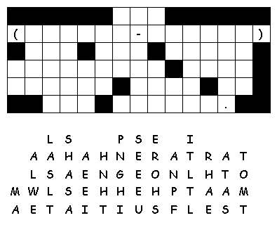

**Nuh (alaihi-salaam)**

1. **Who was Prophet Nuh (alaihi-salaam)?**   
   (He was a man of good character, and the first messenger sent by Allah to the people of the Earth.)
2. **Why did Allah send him as a messenger?**   
   (Because people had fallen into the ways of the non believers, idol worshipping, valuing status and wealth etc.)
3. **How were the people in Nuh's alaihi-salaam community living?**   
   (Badly! They did not know how to worship Allah correctly)
4. **What did Allah SWT command Nuh (alaihi-salaam) to do? Why?**   
   (To build an ark, as all the non believers would perish in the flood Allah planned to send)
5. **How did the people who did not listen to Nuh react?**  
   (They laughed at Nuh (alaihi-salaam)! Called him a crazy man for building a boat in the middle of dry land!)
6. **Who went into the ark?**  
   (Animals in pairs, male and female, and the believers from Nuh’s (alaihi-salaam) community)
7. **Complete the word puzzle below.** The letters to the sentence have all been jumbled up, you need to use all the letters to make a sentence. (Hint, question 1 may be able to give you a clue!)

