**Hajj at a glance** Connect the numbers in the middle with arrows showing the Hajj route

**1**

**IHRAM**

* **Clean yourself**
* **Wear Ihram garments**
* **Make intention for Umrah**
* **Recite Talbiyah**
* **Avoid forbidden acts of Ihram**

**5**

**GOING TO MUZDALIFAH**

* **Leave for Muzdalifah soon after sunset on 9th dhul Hijjah**
* **Perform Maghrib and Isha prayers combined (Isha-shortened to 2 rakahs)**
* **Stay overnight and perform Fajr prayer**

**4**

**GOING TO ARAFAT**

* **Leave for Arafat on morning of 9th Dhul Hijjah and stay until sunset**
* **Stay in any part of Arafat**
* **Glorify Allah, repeat supplication, repent to Allah and ask for forgiveness**
* **Pray Duhur and Asr shortened and combined during the time of Duhur**

**2**

**UMRAH**

* **Make Tawaf around the Kaábah**
* **Pray 2 Rakaáh behind Maqam e Ibrahim**
* **Make Sai between Safa and Marwah**
* **Trim hair and remove Ihram garments**

**3**

**GOING TO MINA**

* **Put on Ihram garments again**
* **Make intention for Hajj**
* **Remain in Mina on 8th Dhul Hijjah and perform the 5 prayers from Duhur to Fajr of 9th Dhul Hijjah**

© 2010 Umamah Learning Academy

**4**

**1**

**7**

**6**

**5**

**3**

**9**

**8**

**2**

**Miqat**

**Arafat**

**Muzdalifah**

**Mina**

**Makkah**

Ka’abah, Masjid al Haram.

Safa & Marwa

8

RETURN TO MINA

* Spend the Tashreeq days in Mina
* After Duhur each day, stone the three Jamarat, starting with the small and ending with Al Aqabah
* You may leave on the 12th after stoning the three Jamarat if you wish

**10**

**GOING HOME**

* **It is preferred to visit the Prohet’s Mosque in Madinah but this is not part of Hajj**.

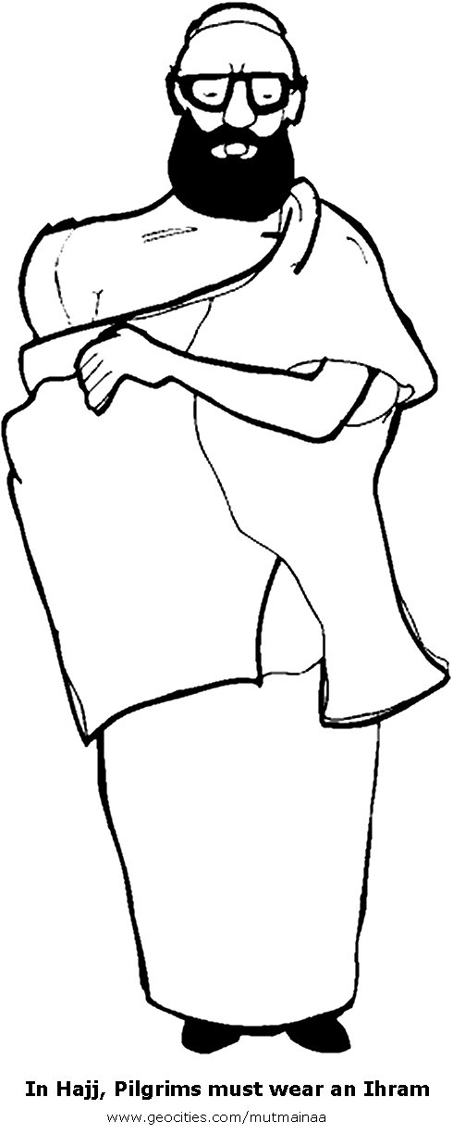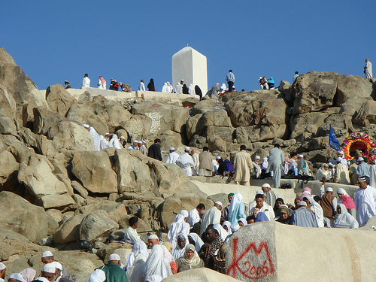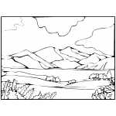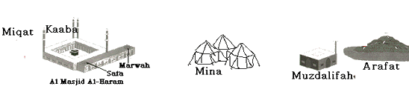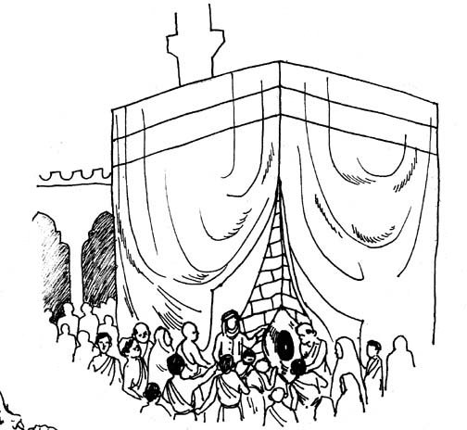

**9**

**FAREWELL TAWAF**

* **Go to Makkah and make farewell Tawaf. Perform 2 rakahs of Tawaf**
* **Let the Tawaf be the last thing you do in Makkah**

7

TAWAF AL IFADHA

* Make Tawaf Al Ifadha
* Make Sa’I between Safa and MArwah
* After Tawaf Al Ifadha , all restrictions are lifted

6

PROCEED TO MINA

* Shortly before sunrise, leave Muzdalifah for Mina. Go to Jamraat Al Aqabah and stone it with 7 pebbles
* Slaughter your sacrifice
* Shave your head or trim hair
* Take off Ihram garments
* All Ihram restrictions are lifted