This Topic is for more mature pre teens and early teens.

**Topic:** Day of Judgement

**Duration:** 4 sessions

**Breakdown:**

**Introduction:**

We started by getting the children to lie down in a darkened quiet room and telling them :

Imagine a hot sunny day, with the breeze gently blowing.

Close your eyes.

You are on holiday, on a beach.  You've just finished making the last part of the sand castle and Dad is heading back to the car to get the food for lunch.

you lie back on the hot sand and it feels good to feel the warmth coming through to your bones. you close your eyes and a blanket of red fills your mind - wonderful warm sunny days!

the sounds of laughter as mum chases Ahmed back from the water, and the thump thump of dad setting up the picnic table fall away as the breeze whispers slightly louder.

and then an eerie silence settles and there is no noise, not even from the group with the big barbecues. you need to open your eyes to see where they've all gone but you are so comfortable and warm on the hot sand and the cool breeze blowing over you,

it seems too much of an effort and then it's cold and in an instant you realise -

you're DEAD!!

**Session 1:**

** What is the Day of Judgement?

** What are its names, it’s importance and it’s time?

** Who is it for?

** How do we return?

** The order and activities of the Awakening.

** The difference between the believers and the non-believers on this day.

Home task for Session 1: Each student to identify the ‘tailbone’ on a skeleton, and research what happens during cremation to the coccyx. Also, what is the connection between the bone named ‘luz’ (Hebrew/Aramaic), the location of the human’s primitive neural tube and the coccyx?

Answers to be discussed in next session inshaAllah.

**Session 2:**

**\*\*** 5 questions

**\*\*** The Records and the Scales

**\*\*** The Pond

**\*\*** Intercession and Testimony

** Judgement

**\*\*** The Bridge

Home task for Session 2: Each student to take away a minimum of 7 ‘Balance sheets’ and make a daily record – one per day.

Bind your records, as you will be bound in a shroud, and decide which hand will these records be received in? Bi yameeni o bishamalee?

Discussion to follow in Session 3 inshaAllah.

**Session 3:**

**\*\*** MinorSigns of the Day of Judgement

From Quran, recorded hadiths in Bukhari, Muslim, Ibn Manhaj etc.

**\*\*** MajorSigns of the Day of Judgement

The 10 Signs: Arising of the Sun from the West, Appearance of Smoke, The Beast, Al-Mahdi, Descent of Isa alais salaam, Yajuj and Majuj, Landslides, and the Fire.

Home task for Session 3:

Watch some videos – about 10 minutes each

Mute sound - <http://www.youtube.com/watch?v=mDT-S61vbrs>

**The Day of Judgement Part 1 (Hasan as-Somali)** <http://www.youtube.com/watch?v=DhCoYiTcQQU>

<http://www.youtube.com/watch?v=bbjTNsZJ37s&feature=related>

<http://www.youtube.com/watch?v=Bzrwt40Gank&feature=related>

**Session 4:**

**\*\*** How does faith in the Day of Judgement affect your life?

Own ideas relating to experiences in their own lives and ‘focus’ poster.

** Developing hate for evil

** Bravery and Heroism

** Patience

** Correct perspective on wealth

** Sense of responsibility

Home task for Session 4: Complete ‘Eyes on the Prize’ Focus Poster.

**References:**

**1. Quran**

**2. Hadiths – Sahih Bukhari and Sahih Muslim**

**3. Knowing The Last Day by M Jibaly**

**Eemaan Made Easy, Part 5, Al Kitaab & AsSunnah Publishing, Lebanon**

**4. Reasons for the Revelation by A Neesaboori. International Islamic Publishing, Riyadh. KSA**

**5. Islamic Education by M Zafar. Aziz Publishers, Lahore. Pakistan**

**6. Signs of the End of the World by Dr Awad.**

**Message of Islam, Hounslow, UK**

**7. What Islam is all About Yahya Emerick, Noorart Publishers**

**Idea of balance and deeds wrap from sister umm haroon**

The Prophet said: "Every human being shall be consumed by the earth but for the coccyx (*'ajbal-dhanab*)."

Narrated from Abu Hurayra by Bukhari, Muslim, Abu Dawud, al-Nasa'i, Ibn Majah, Ahmad, and Malik in al-Muwatta'.

Ibn 'Abd al-Barr said: "The letter of this hadith and its general meaning necessitate that human beings are all undifferentiated in this case, except that it was narrated that the earth does not consume the bodies of Prophets and martyrs."

Ibn 'Abd al-Barr, al-Tamhid (18:173). See Appendix 25, "The Prophets in Barzakh" (p. 455)

**Session 2: - HANDOUT TO WORK ON ALONGSIDE READING IN SESSION**

Did you then think that We created you pointlessly, and then you will not be brought back to Us? (For account) Surah al Muminoon 23:115

**\*\*** Intercession and Testimony

Judgement will not begin till Prophet Muhammed pbuh intercedes.

Allah’s coming, bringing hell into view, carrying of burdens, and no help from kin.

Injustices shown, some will be bankrupt. First to be indicted wee those who did their actions for show.

Covering of sins.

The denial from Shaytan!

**\*\*** 5 questions

How did you consume your life, how did you wear out your body, how did you earn your wealth, how did you spend your wealth, and how did you implement what you knew?

**\*\*** The Records and the Scales

Scales will be huge and deadly accurate. Records of believers and disbelievers handed to them in right or left hand.

**\*\*** The Pond

To fulfil the thirst of the believer, though some will be turned away.

** Judgement

Is final.

**\*\*** The Bridge

The final test to clear what you owe.

Home task for Session 2: Each student to take away a minimum of 7 ‘Balance sheets’ and make a daily record – one per day.

Bind your records, as you will be bound in a shroud, and decide which hand will these records be received in? Bi yameeni o bishamalee?

Discussion to follow in Session 3 inshaAllah.

Scales will be huge and accurate.

Label what will make the scales heavy, and which types of action would only be considered light.

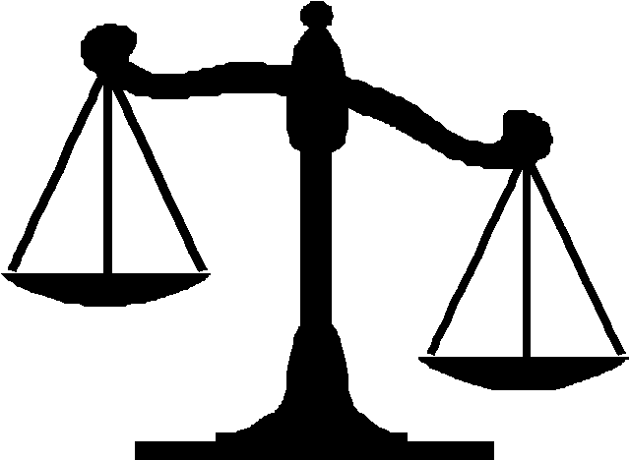

RECEIVED IN RIGHT HAND

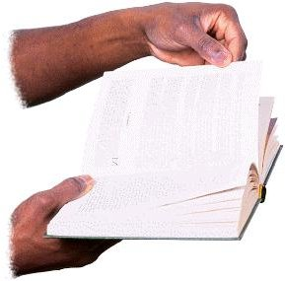

RECEIVED IN LEFT HAND

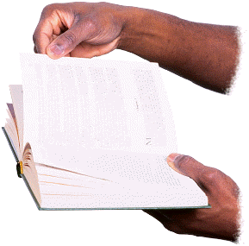



The Bridge: SIRAT

We don’t know how scary crossing the sirat will be! This is the Sky Bridge in Langkawi, Malaysia. It is a majestic cable-stayed bridge supported by only one support column as it wraps its way around a mountain a whopping 2,250 feet above sea level.

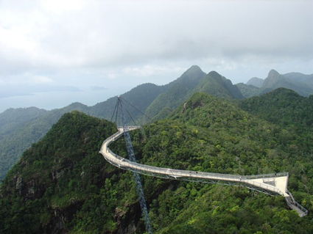

This is a basic rope bridge!

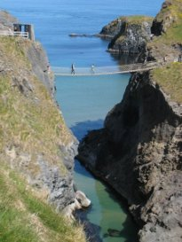

Draw your own idea of what crossing the Sirat would be lie bearing in mind the verses we’ve just read!