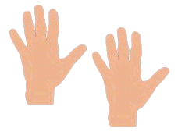
Allaah gave me my two hands
With them I can hold
With them I can lift up things
Stretch and also fold.
So I thank Allaah for this
For giving me hands – two
They’re a blessing from Allaah
So much with them I do!

