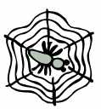
The little spider spins her home
A soft and silky bed!
So do not raise your hand to harm
Her gentle silver web!
Busy night and day she weaves
Spinning threads of beauty
She is Allaah's little creature
Carrying out her duty.

