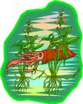
Lots of fish upon the tide
They go swimming side by side
Underwater they abide
And on the waves they ride!
Allaah made their home, the sea
So the fish swim happily!
Colourful, big and small
Allaah made them all.

