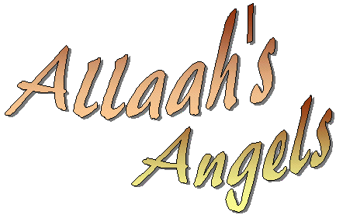
Allaah made His noble Angels
Made them all from light
They perfectly obey Allaah
And do their duties right.
The Angel Jibraa’eel came forth
And brought down al-Qur’aan
So peace be on this noble Angel
Say ‘Alayhis-salaam’.
The Angel Meekaa’eel takes charge
Of rain and plants, you see
So peace be on this Angel too
Who’s helping you and me!
The Angel Israafeel, one Day
Will blow the Trumpet clear
So peace be on this Angel too
That Day could be so near!
Then there are Angels writing things
One on the left and right
They know the things we say and do
They’re with us day and night.
Allaah has made lots of Angels
Good and kind and true
The Angels love and pray for us!
So let’s all love them too!

