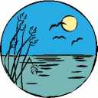
Allaah's birds fly through the air
Sailing through the sky
Whizzing past the clouds they go!
See them up so high!
Look a moment at their body
See their two soft wings?
Do you know how they can fly
Without any strings?
Only Allaah is the One
Who makes the birds fly
Allaah lifts them up, up high!
To the giant sky!

