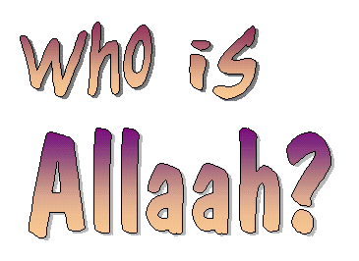
Allaah is the One Who made us
You and also me!
Allaah made the whole wide world
And all the things we see.
Allaah, He knows everything
He knows the things we do
Allaah hears and sees all things
And knows what we’re up to.
Allaah, He looks after us
And gives us life to live
He gives us clothes and food and health
All good things He does give.
Allaah, He protects us all
And keeps us far from harm
He gives us shelter from the cold
And keeps us safe and calm.
Allaah is the One Who guides
He tells us what to do
Allaah says to worship Him
This way we’ll be good too.
Allaah is our One best Friend!
There’s none like Him for sure!
The Kindest One and Merciful
So let’s love Allaah more!

