Pop-Up Kabba Eid Cards

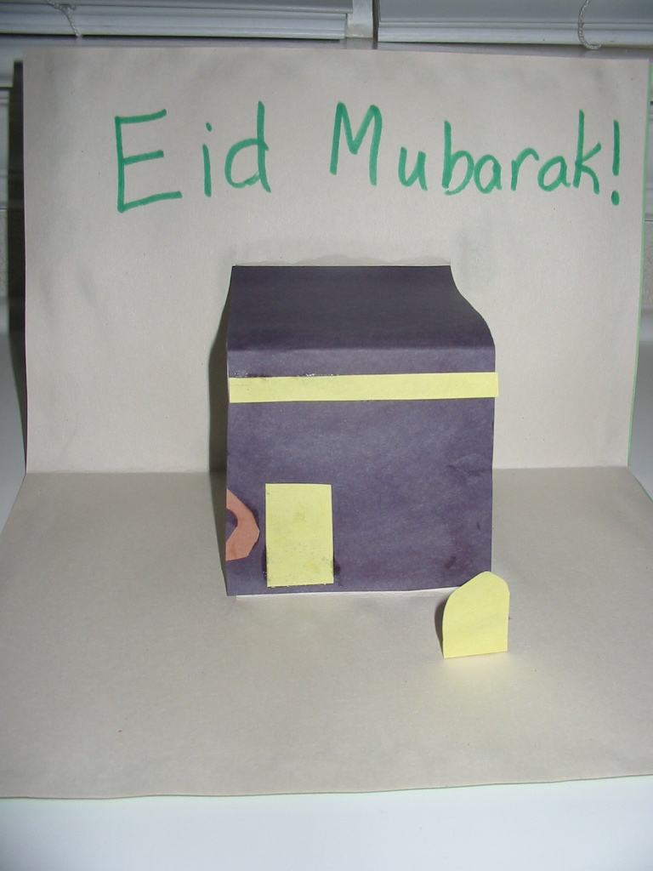

Materials:
Construction paper (at least two to three pieces per child)
Black and yellow construction paper
Scissors
Glue
Crayons or Markers

Directions:
1. Give each child one light colored piece of construction paper and one dark piece of construction paper. Fold both pieces of paper in half the short way.

2. Fold the lighter paper in half again the long way and open it again to make a crease. Cut two slits about four inches apart in the lighter colored paper from the fold to the crease.

3. Pop out or invert the section of the paper with the slits. This will be the Kabba that will pop out with the reader opens the card. Have campers glue the lighter colored paper to the darker colored paper, being sure NOT to glue down the part that pops out.

4. Cut out a rectangle of black paper to cover the popped out Kabba and make it black. Cut out a thin strip of yellow paper to glue a gold border along the top of the Kabba. Campers can also use the yellow paper to make a gold door for the Kabba. Finally, each camper decorates the outside and inside of the card with messages like Eid Mubarak!!

