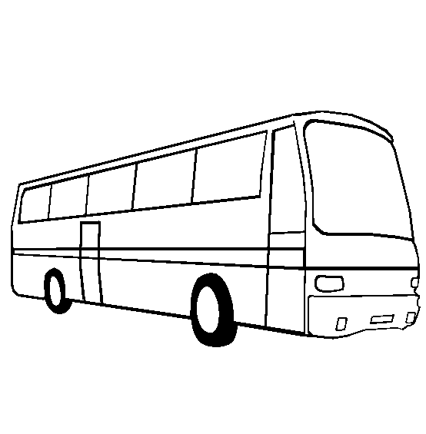

Leave for ______ early in the morning on the 8th of Dhul Hijjah. Recite the Talbiya on the way and stay overnight in Mina. 4
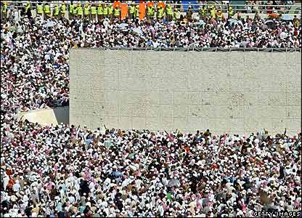

Go back to Mina on the 10th of Dhul Hijjah and stone of the Jamarat walls. Choose an _________ for sacrifice and trim or shave your _______. You do this for two more days. 6
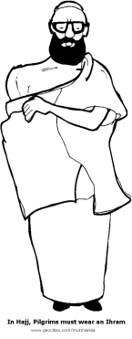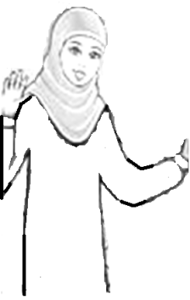

Muslims must wear the ___________ before they go on Hajj. For men that is ______ unstitched pieces, and for women it is their regular clothes. 2

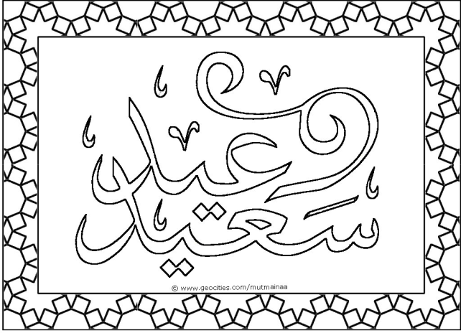

Muslims who don’t go on Hajj, celebrate ________________ at home. They go to salah and they also sacrifice an animal. They give some of the sacrifice to poor people. Muslims make dua during Eid ul-Adha and are very happy during this time. 8

