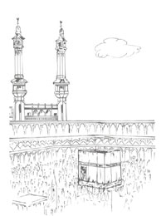

Name: ______________________________________ 1

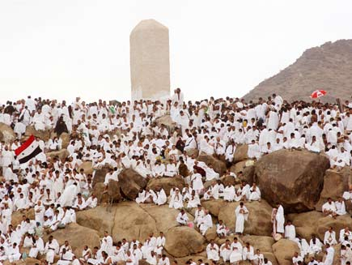

Go to _________ and pray Zuhr and Asr. Stand here and make dua to Allah for forgiveness. Arafat is very important. In the evening move to Muzdalifah and say Maghrib and Isha. Rest ther at night and collect small pebbles. 5
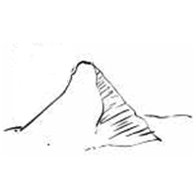

We enter Mecca and perform ___________ seven times around the Kaaba. Then we walk between the two hills ___________ and ____________. This is called Sai.’ 3
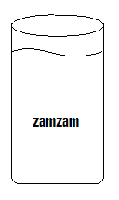

After you finish stoning Jamarat for three days, you return to Mecca. Perform ________ around the kaaba and then drink ________ water. This ends the Hajj. 7

