Name: _____________________________________________________________

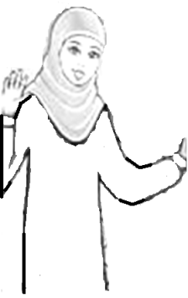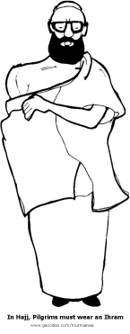

Some of the steps for Hajj are missing below. Write in the steps for Hajj in the blanks. Color the pictures after you are finished.

3. Leave for ______ early in the morning on the 8th of Dhul Hijjah. Recite the Talbiya on the way and stay overnight in Mina.

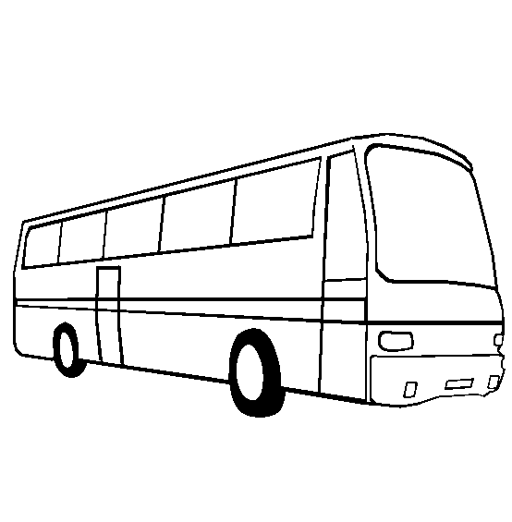

2. We enter Mecca and perform ________ seven times around the Kaaba. Then we walk between the two hills _____ and _________. This is called Sai.’

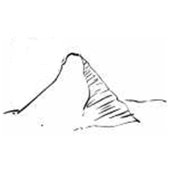

1. Muslims must wear the ___________ before they go on Hajj. For men that is ______ unstitched pieces, and for women it is their regular clothes.

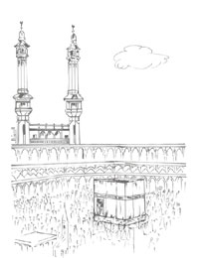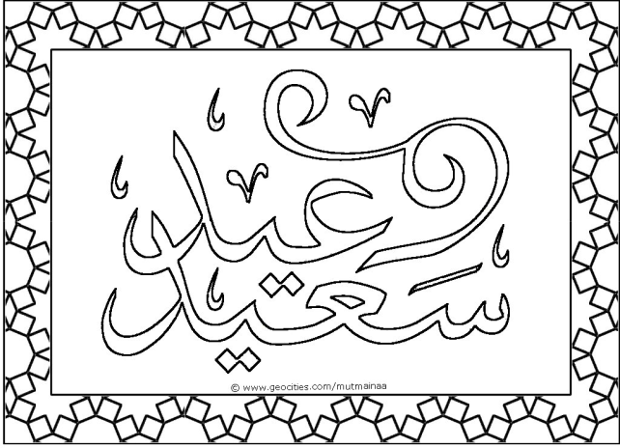

Muslims who don’t go on Hajj, celebrate ________________ at home. They go to salah and they also sacrifice an animal. They give some of the sacrifice to poor people. Muslims make dua during Eid ul-Adha and are very happy during this time.

5. Go to _________ and pray Zuhr and Asr. Stand here and make dua to Allah for forgiveness. Arafat is very important. In the evening move to Muzdalifah and say Maghrib and Isha. Rest ther at night and collect small pebbles.

6. Go back to Mina on the 10th of Dhul Hijjah and stone of the Jamarat walls. Choose an _________ for sacrifice and trim or shave your _______. You do this for two more days.

7. After you finish stoning Jamarat for three days, you return to Mecca. Perform ______ around the kaaba and then drink ________ water. This ends the Hajj.