© 2010 Umamah Learning Academy

When the pilgrim raises his voice with **Talbiyah**, he remembers that he answers the call of Allah and that there will be another call on the Last Day, when people will be either punished or rewarded.

**Here I am O Allah! Here I am!**

**Here I am you have no partner, here I am,**

**Surely Yours is all praise, all goodness**

**And All Sovereignty and You have no partner**

لَبَّيك اَللّهُمَّ لَبَّيك

لَبَّيكَ لا شَريكَ لَكَ لَبَّيك

إِنَّ الْحَمْدَ وَ النِّعْمَةَ

لَكَ وَالْمُلْك

لا شَرِيكَ لَكْ

ح

حَجْ

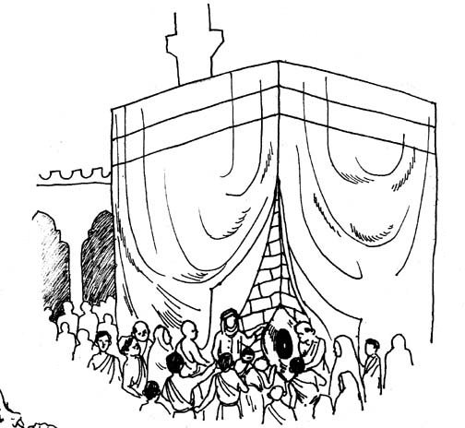

تلبيه

ت