Hajj Activities

1. CREATIVE ARTS  Songs (PreK-2)  Go to Hajj (to the tune of Row your Boat)  Go, go, go to hajj  Any way you can  Verily, verily, verily, verily  Do what Allah Commands. | 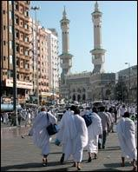

To Makkah, To Makkah (to the tune of To Market, To Market)  To Makkah, to Makkah  On hajj we all go  Home again, home again  We loved it so. | 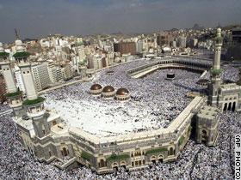
Art
a. Make Eid cards (All grades)
b. Make a Kabah moneybox from a square tissue box. (PreK-2) Paint black with a yellow/gold line around.
c. Make a diorama about what hajj means to the student. (Middle Primary)
d. Make a quilled sheep. (Upper Primary) Draw an outline of a sheep on A4 paper. Apply glue to the sheep. Using black quilling paper (which are thin strips of paper about 0.5cm wide) twirl it around a pen/pencil, remove from pen/cil (but keeping the curled shape) and place it onto the glue so that it lays flat. What students should end up with is a sheep with curly black wool. (Search quilling techniques for more details on how to do quilling.) Alternatively, use black paper for the sheep and white quilling paper for the wool.

2. ENGLISH
Read Hajj is book. (PreK-2)
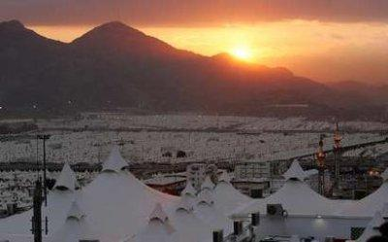
Write a procedure on how to perform hajj. (Middle-Upper Primary)

3. SCIENCE
Transportation Getting to Hajj. Study the different transportation needed to go to hajj.
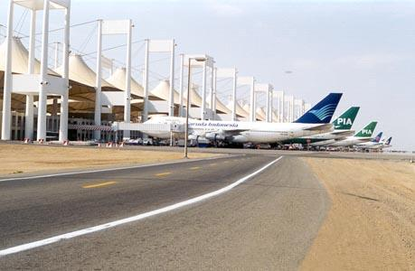 | 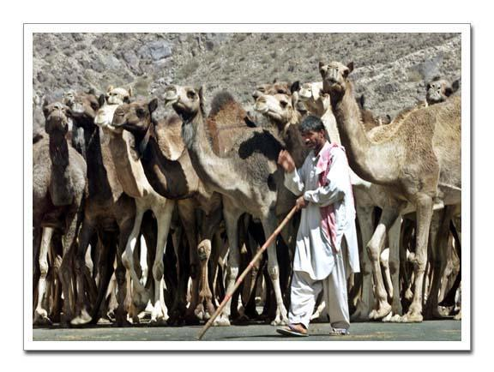

Classification. PreK-2) Classify and categorise the animals that can be used as sacrifice sheep, lamb, ram, camel, cow, chicken.

4. MATH
The number 7. (PreK-2)
a. Collect stones and put into a basket. Have children count out 7 stones.
b. From the basket of stones, have children count out 3 groups of 7. How many all together?
Cube shape. (PreK-2) Learn about the cube and the sphere. Make a cube from black paper. Draw in the gold lines to make it look like the Kabah. Compare with a small ball.

6. HSIE
Geography
a. Saudi Arabia. Study the places of hajj.
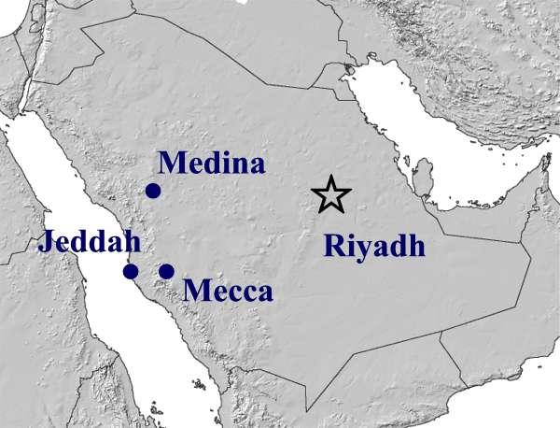
History
a. Story behind Sai (Hajar and baby Ismail and zamzam)
b. Story of the Sacrifice (Prophet Ibrahim and Ismail including stoning of shaytan)
c. Building of the Kabah
d. Prophet Muhammad’s hajj (including tawaf, Arafat)

7. PDHPE
a. Pretend to go around the Kabah and Sai seven times. Vary the pace - do it at a normal pace at first, then slow, then fast.

