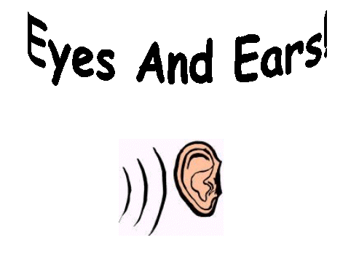
Allaah gave me my two eyes
And He gave me ears
With my eyes I see the world
With my ears I hear.
So I thank Allaah for this
So much He's given me!
I will try with them inshaa Allaah
Good things - hear and see!

