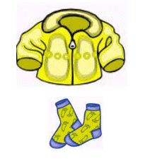
I thank Allaah for all my clothes
Lots I have to wear!
But there are people who have less
And their feet are bare.
No shelter from the cold they have
No woollies warm to wear
So I will try to help them all
And show them that I care.
WHEN YOU WEAR A GARMENT:
Alhamdulillaah-hilladhee kasaanee haadhathawba wa razaqaneehi min ghayri hawlimminnee wa laa quwwa
This du’aa means: All praise is for Allaah who has clothed me with this garment and provided it for me, with no power nor might from myself. [Aboo Daawood and others]

