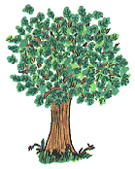
Before you cut down any tree
Look up high and you will see
Branches moving with the breeze
Green and healthy growing leaves.
Swaying in the morning sun
Allaah made the trees - each one
So we all must really try
Not to let the good tree die!

